Upgrading ActivHub firmware
Firmware is a small program on Promethean devices that controls basic functionality.
We continuously improve our firmware and recommend that you regularly check for upgrades.
Why upgrade?
To make sure that the ActivHub supports the latest Promethean products and features.
What do I need?
Computer with Promethean’s ActivDriver version 5.5 or later installed
ActivHub
We recommend:
That you upgrade the ActivHub first, then reset the ActivHub to clear all registered devices, and then upgrade your Promethean devices.
That you do not remove the ActivHub from the USB port during the upgrade process as this may damage the ActivHub.
If you are performing the upgrade on a laptop, we recommend that the laptop is mains-powered. If this is not possible, make sure that the laptop battery has sufficient charge to complete the upgrade. If you think the battery may not be sufficiently charged, do not begin the upgrade.
How does the upgrade process work?
You start the process from ActivManager on your computer.
Once you have started the process, a progress bar in ActivManager indicates the percentage of information sent. The ActivHub upgrade is complete when progress reaches 100%. ActivManager then restarts the ActivHub. While the ActivHub restarts, its red light flashes a few times. When its green light flashes, the upgraded ActivHub is ready for use.
How can I find out if I need to upgrade?
Plug your ActivHub into a USB port, then check if new firmware is available:
 | Click the ActivManager icon  and select Control Panel. | 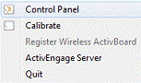
 | Select ActivHub from the list. | 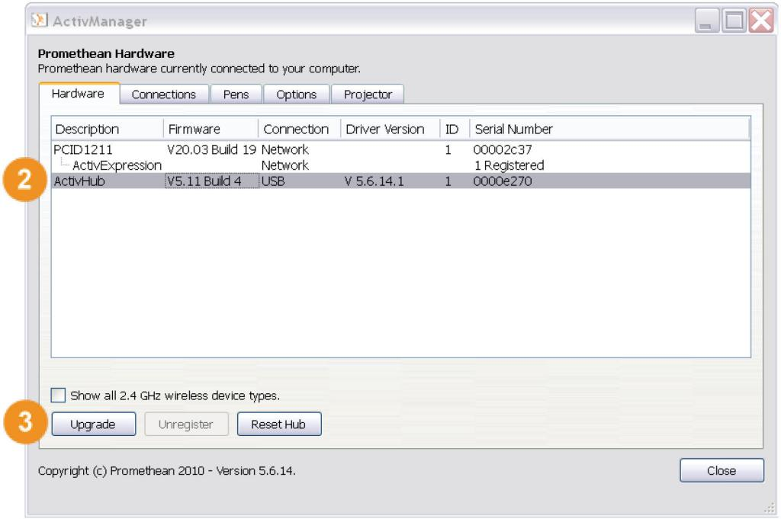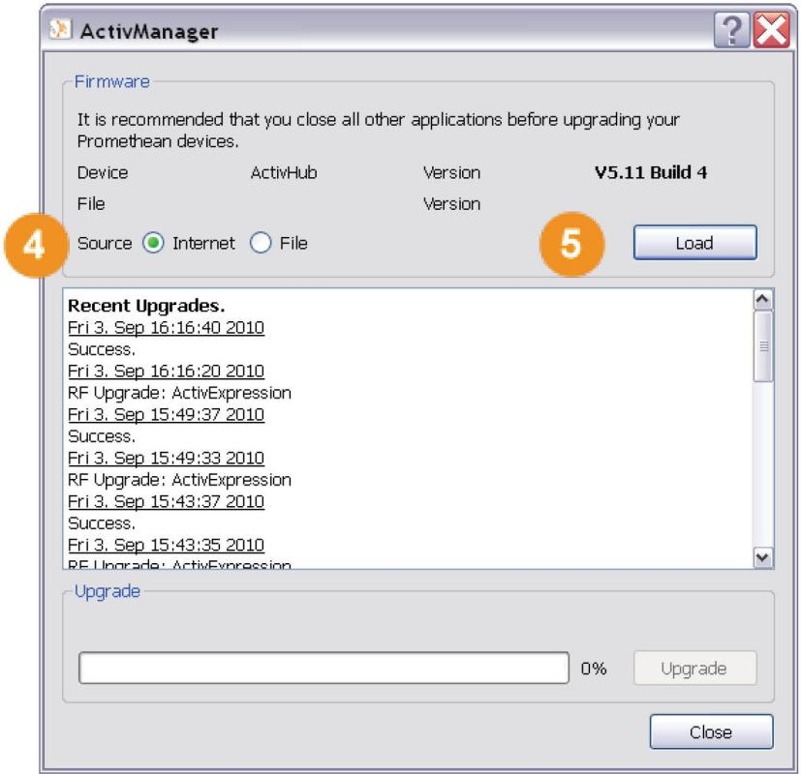  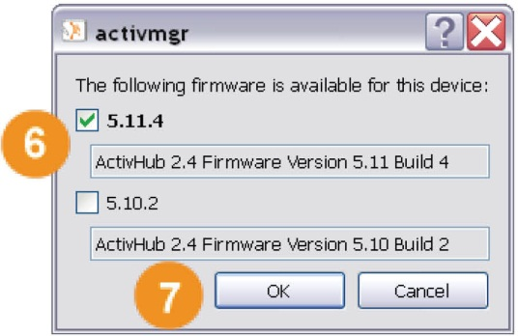
 | Click Upgrade.
 | Select Internet as the source.
Click Load. ActivManager checks if new firmware is available for downloading.
If you already have the latest firmware, the dialog displays a confirmation message.
In that case, click Close and remember to periodically check for updates.
If new firmware is ready for downloading, a Popup window opens listing the available choices.
The latest version is selected by default.
 | Click OK in the Popup window. A confirmation dialog opens. | 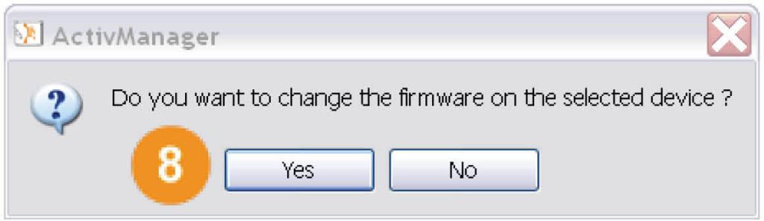  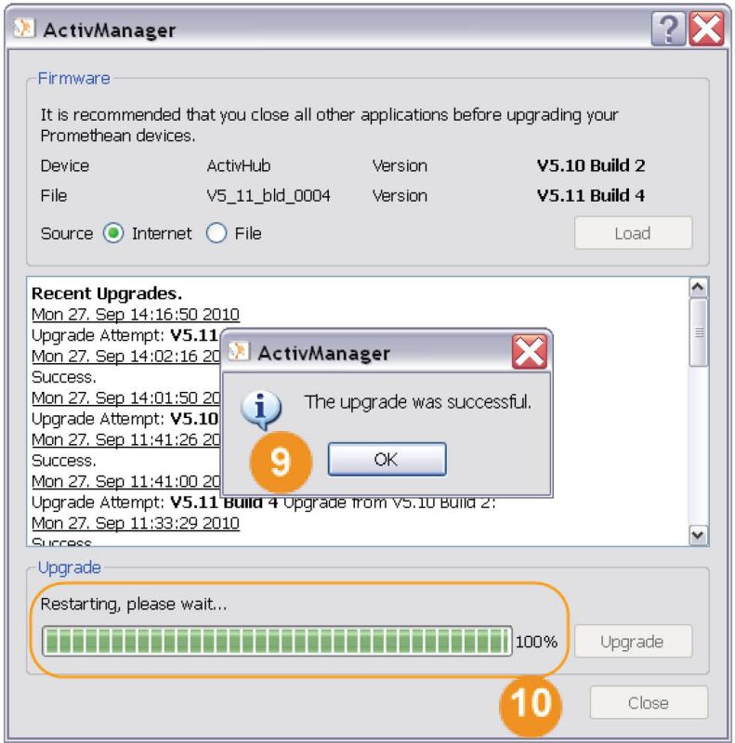
Click Yes to begin the upgrade.
The upgrade begins, and the progress bar indicates the percentage of information sent.
A confirmation dialog opens when the upgrade is complete and the ActivHub has been automatically restarted.
Click OK.
 | Click Close.
Reset the ActivHub
 | Select ActivHub from the list. | 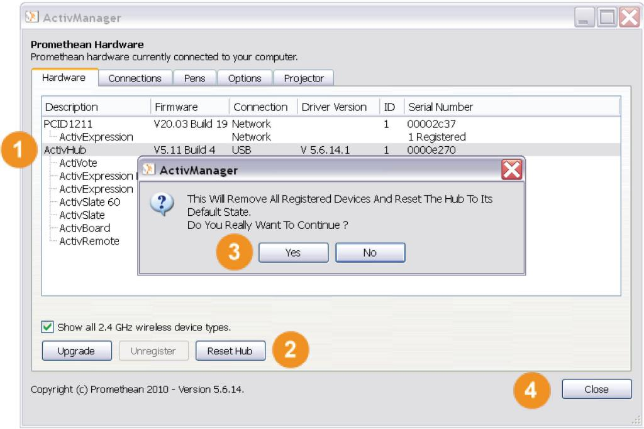
 | Click Reset Hub. A confirmation dialog opens.
 | Click Yes. The ActivHub is reset and the list shows that there are no devices registered.
 | Click Close.
Questions or concerns?
If you have any concerns, or for self-help solutions and further support contact information, please visit the Promethean Knowledgebase.

